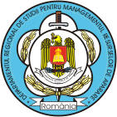
REGISTRATION FORM

Regional Department of Defense Resources
Management Studies (DRESMARA)

The 4th Annual Scientific Papers Session with international attendance:

“INTEGRATED DEFENSE RESOURCES MANAGEMENT IMPACT ON INTERNATIONAL MISSIONS ACCOMPLISHMENT AND ITS SYNTHETIC INDICATORS-BASED ASSESSMENT”
Brasov, 20 November 2009

Scientific Title
Last Name
First Name
Contact address
Institution / University
Department / Faculty
Phone
Email
Paper Title 1
Paper Title 2

